Update raspberry Pi 4 notes(28/12/2022):

1. Download SD card formatter here, <https://www.sdcard.org/downloads/>
2. Insert the SD card to the computer and format SD card using the formatter

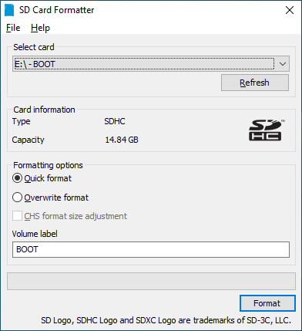

1. Download Raspberry Pi Imager here, <https://www.raspberrypi.com/software/>
2. Open the Imager, choose the options as below and upload Raspberry Pi OS to the SD card
3. Set the operating system: RASPBERRY PI OS (32-BIT) , storage(SD card) and setting on below icon showed(in red box)

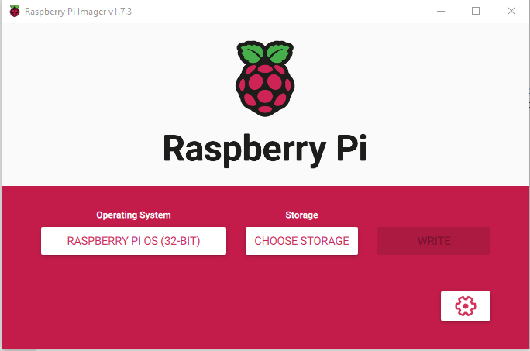

a

1. Set username as default : raspberrypi , and choose enable the SSH – use password authentication

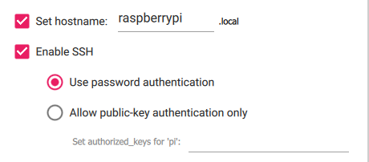

7.Set Username: ‘any name’ and password : ‘ any password’

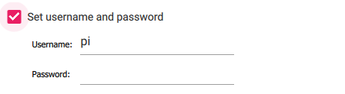

1. Set the locale settings Time Zone and Keyboard :

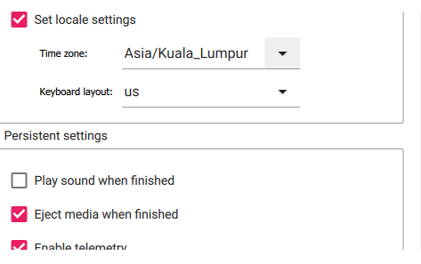

8. After done,remove the sd card and plug-in into the raspberry pi device.

9. Enter the ssh mode in the CMD or Putty, then type the below command:

* sudo apt-get install
* sudo apt-get update
* sudo apt-get upgrade
* sudo apt-get install xrdp
* sudo apt-get install tightvncserver
* sudo apt install realvnc-vnc-server realvnc-vnc-viewer

1. Before open the VNCViewer , go to “ sudo raspi-config” and select no.3 interface options 🡪 no.3 enable the VNC server.
2. After enable the VNC viewer , need to change the resolution to 1280 x 720 or the highest value.(16:9).
3. To enable the pi camera in the VNC viewer, please refer to this link provide below

: “https://youtu.be/dbBWyeHbGs0”

1. How to solve the ssh problem :

* Simplest solution is to just remove /Users/admin/.ssh/known_hosts and let it get recreated.(in PC not in SD card)

1. How to solve “wifi currently blocked by rfkill”

* In cmd ssh / putty type “sudo raspi-config”
* Go to 5. localization options: choose MY-malaysia – reboot system

1. How to set the WLAN SSID

* Type sudo raspi-config
* Choose No.1 and set ur SSID and Password, reboot